EDUCATIONAL ORGANIZATION USING SERVICENOW

Team Id: NM2025TMID15640
Team Members: 4
Team Leader: SANJAY RAMA SWAMY J
Team Member 1: PRAGADEESH RAJ C
Team Member 2: NOBLE ANBUNESAN
Team Member 3: KEERTHIGA S
Problem Statement:
Educational organizations face difficulties in handling student queries, staff requests, IT support, and administrative tasks when managed manually. This leads to delays, errors, and lack of transparency. As a result, processes become inefficient and cause dissatisfaction among students and staff.

Objective:
1. Automate service requests and ticketing system:
Instead of writing complaints or requests manually, the system will automatically create and track tickets, making it faster and easier to manage.
2. Improve communication between students, staff, and administration:
ServiceNow provides a single platform where students, staff, and administrators can easily share information and updates, reducing miscommunication.
3. Reduce response time for IT and administrative issues:
By automating workflows, requests like login problems, Wi-Fi issues, or certificate needs can be solved quickly without unnecessary delays.
4. Provide a centralized platform for service management:
All types of requests (student, staff, IT, admin) can be managed in one place, ensuring transparency, easy tracking, and better efficiency.

Skills:
ServiceNow Platform, Database Management, Scripting, Problem-Solving & Analytical Skills, Documentation & Reporting, Project Management, Communication Skills, Time Management
TASK INITIATION:
Milestone 1: Setting up ServiceNow Instance
Activity 1: Setting up ServiceNow Instance
Step 1: Search a developer.servicenow.com
Step 2: Sign in ServiceNow.
Step 3: Click on “Request Instance”.
Step 4. Submit the request.
Step 5. Log in to your ServiceNow Instance.
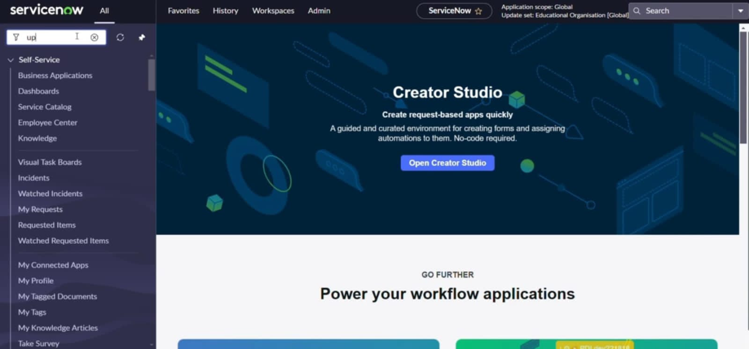
Milestone 2: Creating a Update Set
Activity 1: Creating a Update Set
Step 1. Click on All >> Local update sets.
Step 2. Click on new
Step 3. Enter the Details Name: Educational Organisation.
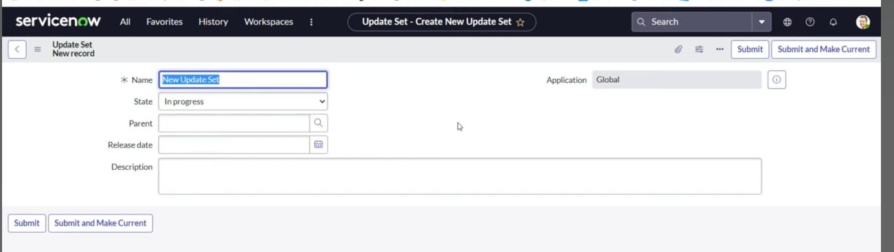
Step 4. Click on Submit and make Current.

Milestone 3: Creating a Table
Activity 1: Creating Salesforce Table
Step 1. Search Tables.
Step 2. Click on New.
Step 3. Enter the label: Salesforce.
Step 4. Click on name.
Step 5. Create a column, double click the column.
Step 6. Enter the column and click the tick mark.
Step 7. Fill the Admin Name>>Save.
Step 8. Click on Controls>> Enable Extensible.
Step 9. Admin Number>>advanced view>>default value.
Step 10. Select get next padded number in Dynamic Default Value>>Update.
Step11. Click on Grade>>choices and label the value>>Update.
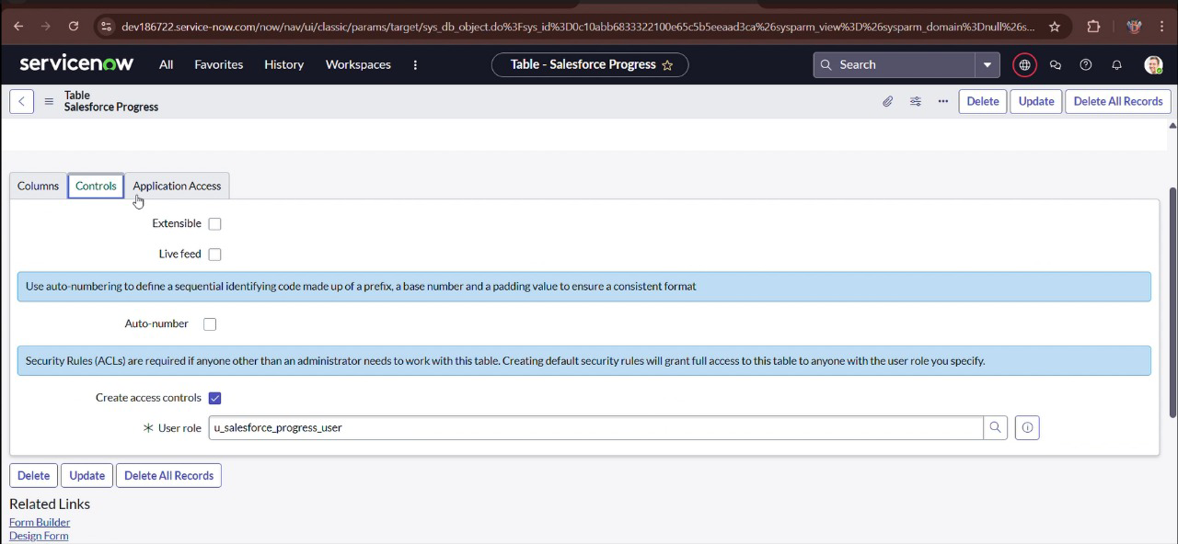

Activity 2: Creating Admission Table
Step 1.All>>Table>>New.
Step 2. Label: Admission>>Name>>Select extend Table.
Step 3.Salesforce, Add module to menu.
Step 4. Create fields.
Step 5. Create a Admin status.
Step 6. Create choices for Pincode.
Step 7. Create choice for Purpose of Join.
Step 8. Create choice for School.
Step 9. Create choice for School Area.

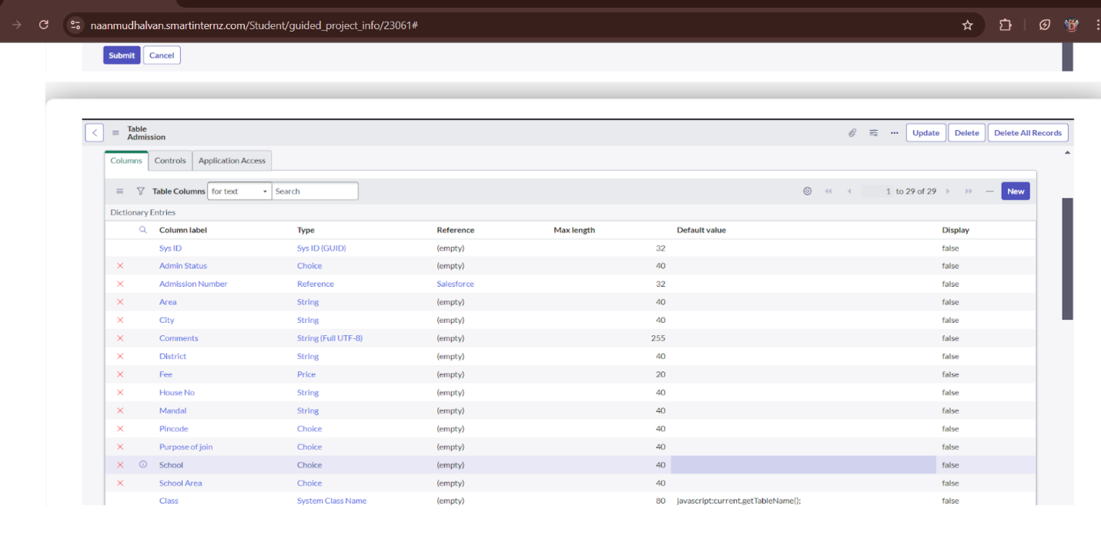
Activity 3: Creating Student Progress Table
Step 1. Create a Student Progress Table with Columns given.
Step 2. Select Add module to menu >>Salesforce.
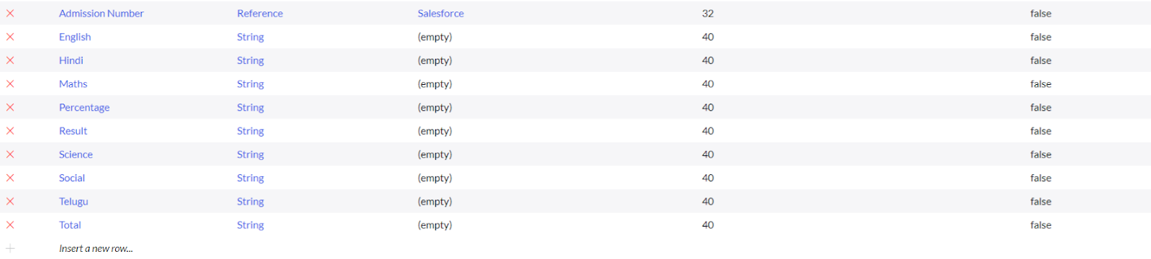
Step 3. Create Fields as shown:

Milestone 4: Form Layout
Activity 1: Configuring Table form for Student Progress Table
Step 1.In the Student Progress Table Page, Click on Layout form.
Step 2.Click on Admission Number.
Step 3. Select below Admission Number fields in Available side.
Step 4. Send it to selected side as below >> save.
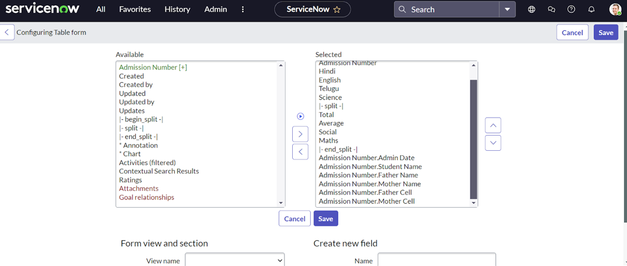

Milestone 5: Form Design
Activity 1:Creating Form Design for Salesforce Table
Step 1.All >> System Definition >> Tables.
Step 2.In Label Search for Salesforce and open.
Step 3. Right Click on top Toggle >> Configure >> Form Design.
Step 4. In drop down select Salesforce(u_salesforce).
Step 5. Drag and drop the fields to the left side as below.
Step 6. Save.

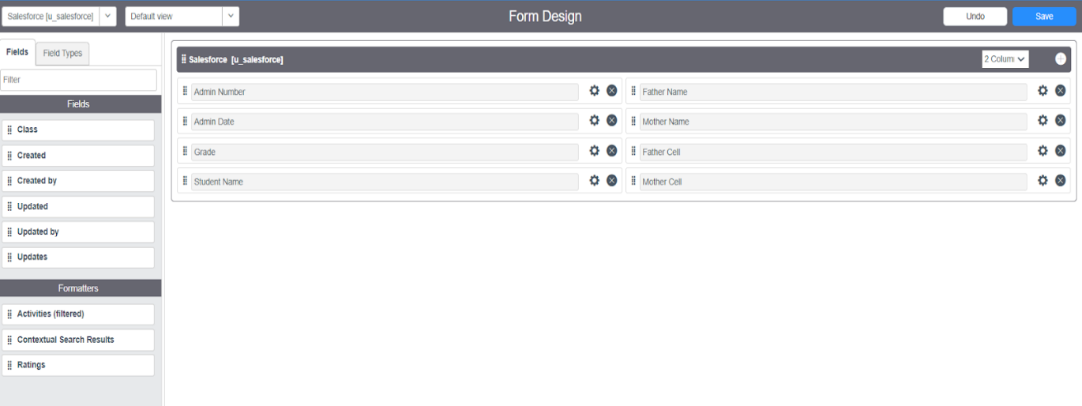
Activity 2:Creating Form Design for Admission Table
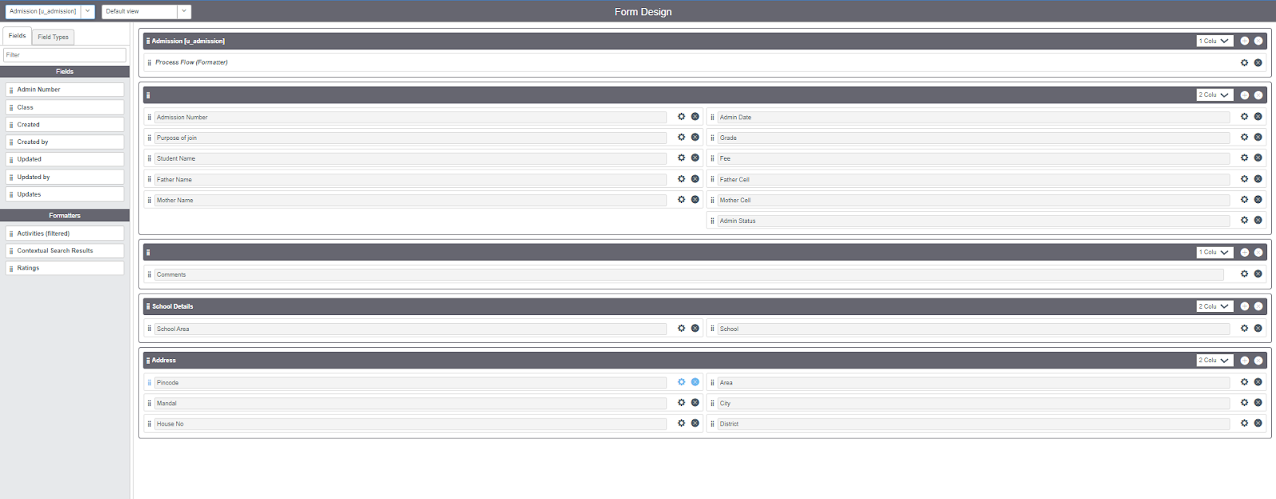
Step 1. Follow the same steps as Activity1, Configure the fields as below and Save.

Activity 3: Creating Form Design for Student progress Table
Step 1. Follow the same steps as Activity1, Configure the fields as below and Save.
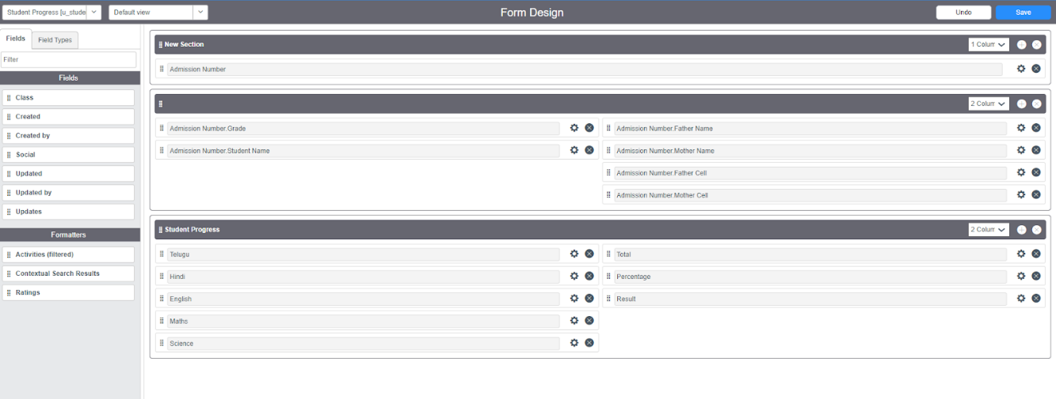

Milestone 6: Number Maintenance
Activity 1:Creating Number Maintenance for Admin Number
Step 1. All >> Number Maintenance >> New
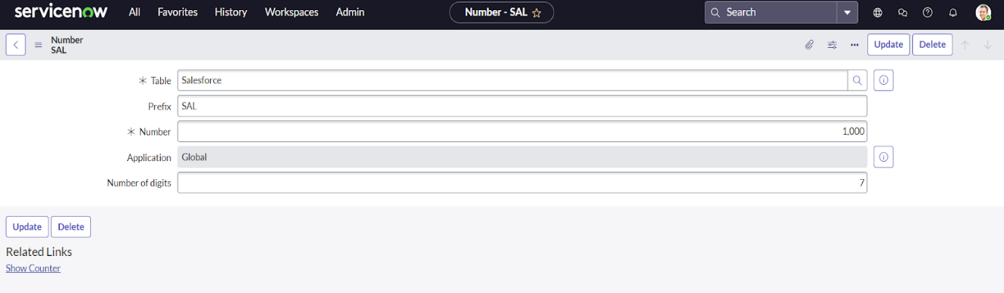
Step 2. Fill the details >> Submit.

Milestone 7: Process Flow
Activity 1: Creating Process Flow for Admission Table
Step 1.All >> Process Flow>> New.
Step 2. Fill the Details as given Below.
Step 3.Right Click on toggle and click on the save.
Step 4. Replace the Name and Label as below and click on Insert on stay.
Step 5. Replace the Name and Label in order and click on Insert on stay.
Joined >> Rejected >>Rejoined>> Closed >> Cancelled.
Step 6. Order should be New >>InProgress>> Joined >> Rejected >>Rejoined>> Closed >> Cancelled.
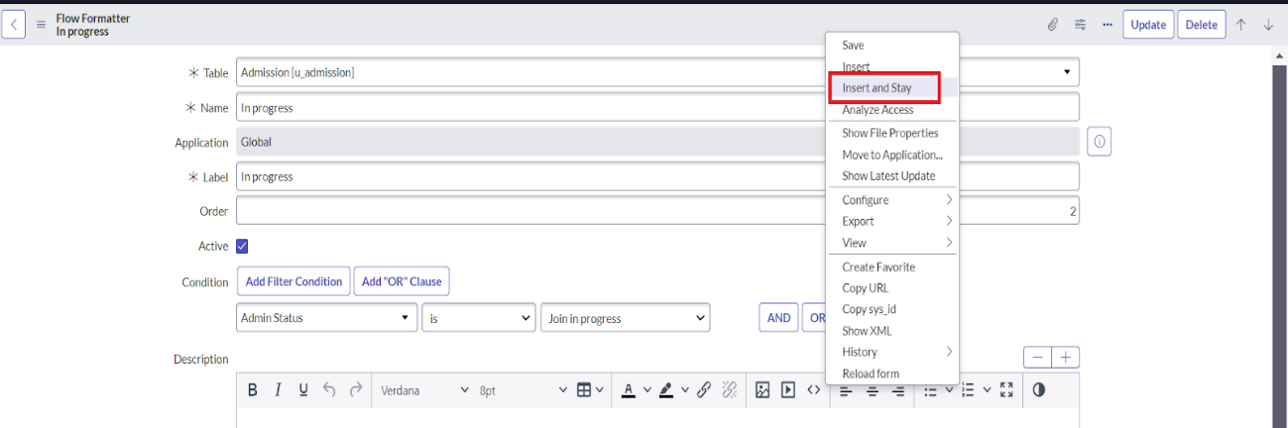

Milestone 8: Client Script
Activity 1: Creating “Auto populate” Client Scripts for Admission Table
Step 1.All >> Client Scripts >> New.
Step 2. Fill the Details as given.
Step 3. Write the Code as below, Enable Isolate script and Save.
functiononChange(control, oldValue, newValue, isLoading, isTemplate) {
if (isLoading || newValue === '') {
return;
}

//Type appropriate comment here, and begin script below
var a = g_form.getReference('u_admission_number');
g_form.setValue('u_admin_date',a.u_admin_date);
g_form.setValue('u_grade',a.u_grade);
g_form.setValue('u_student_name',a.u_student_name);
g_form.setValue('u_father_name',a.u_father_name);
g_form.setValue('u_mother_name',a.u_mother_name);
g_form.setValue('u_father_cell',a.u_father_cell);
g_form.setValue('u_mother_cell',a.u_mother_cell);

g_form.setDisabled('u_admin_date',a.u_admin_date);
g_form.setDisabled('u_grade',a.u_grade);
g_form.setDisabled('u_student_name',a.u_student_name);
g_form.setDisabled('u_father_name',a.u_father_name);
g_form.setDisabled('u_mother_name',a.u_mother_name);
g_form.setDisabled('u_father_cell',a.u_father_cell);
g_form.setDisabled('u_mother_cell',a.u_mother_cell);
}
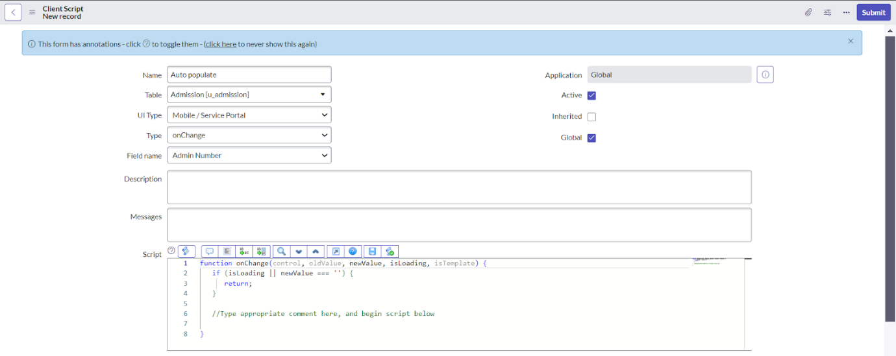
Activity 2: Creating “Pincode Update” Client Scripts for Admission Table
Step 1. Fill the Details as given.
Step 2. Write the Code as below, Enable Isolate script and Save.
functiononChange(control, oldValue, newValue, isLoading, isTemplate) {
if (isLoading || newValue === '') {
return;
}
var a = g_form.getValue('u_pincode');
if(a == '509358')
{
g_form.setValue('u_mandal', 'kadthal');
g_form.setValue('u_city', 'kadthal');
g_form.setValue('u_district', 'RangaReddy');
}
else if(a == '500081')
{
g_form.setValue('u_mandal', 'karmanghat');
g_form.setValue('u_city', 'karmanghat');
g_form.setValue('u_district', 'RangaReddy');
}
else if(a == '500079')
{
g_form.setValue('u_mandal', 'Abids');
g_form.setValue('u_city', 'AsifNagar');
g_form.setValue('u_district', 'Hyderabad');
}
}
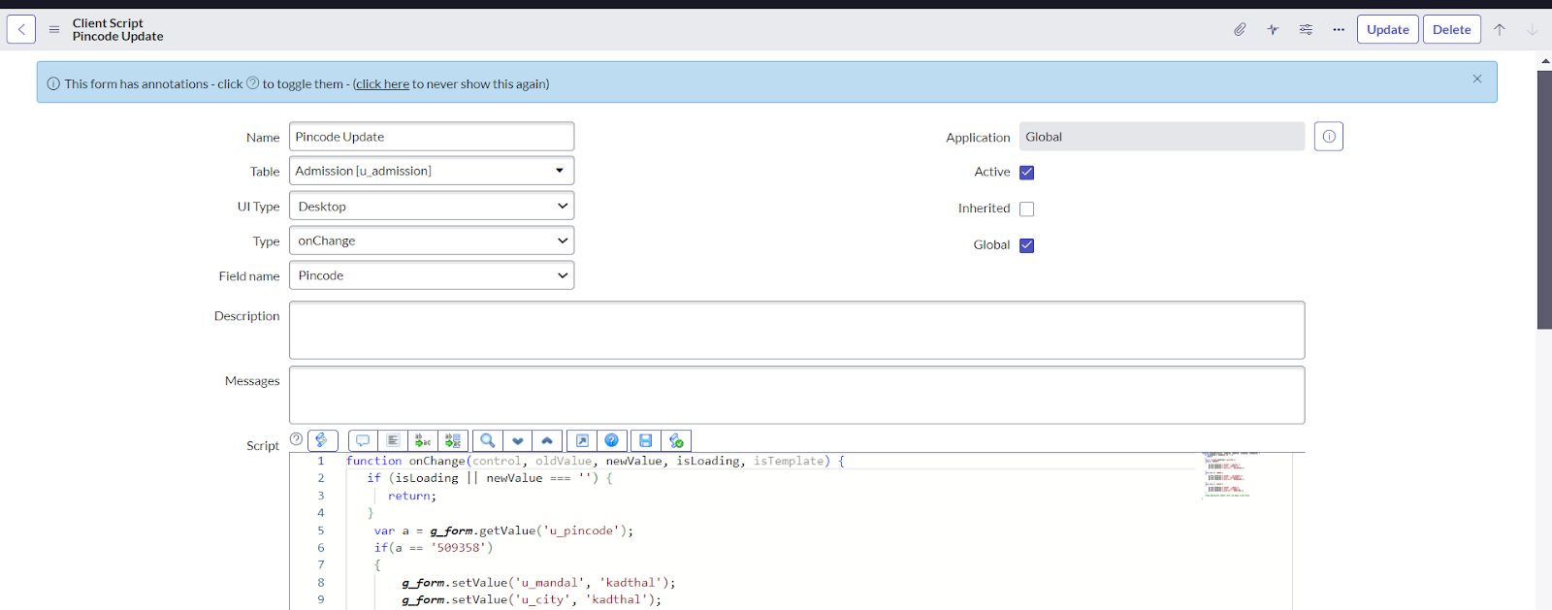

Activity 3: Creating “Disable Fields” Client Scripts for Student progress Table
Step 1. Fill the Details as given.
Step 2. Write the Code as below, Enable Isolate script and Save.
functiononLoad() {
//Type appropriate comment here, and begin script below
g_form.setDisabled('u_total',true);
g_form.setDisabled('u_percentage',true);
g_form.setDisabled('u_result',true);
}

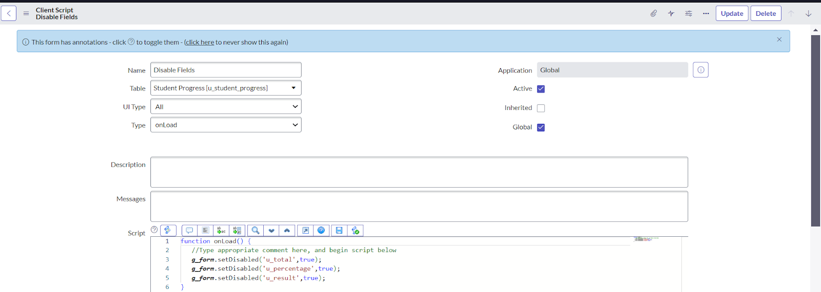
Activity 4:Creating “Total Update” Client Scripts for Student progress Table
Step 1. Fill the Details as given.
Step 2. Write the Code as below, Enable Isolate script and Save.
functiononChange(control, oldValue, newValue, isLoading, isTemplate) {
if (isLoading || newValue === '') {
return;
}
//Type appropriate comment here, and begin script below
if (newValue){
var a = parseInt(g_form.getValue('u_telugu'));
var b = parseInt(g_form.getValue('u_hindi'));
var c = parseInt(g_form.getValue('u_english'));
var d = parseInt(g_form.getValue('u_maths'));
var e = parseInt(g_form.getValue('u_science'));
var f = parseInt(g_form.getValue('u_social'));
var Total = parseInt(a+b+c+d+e+f);
g_form.setValue('u_total', Total);
}
}
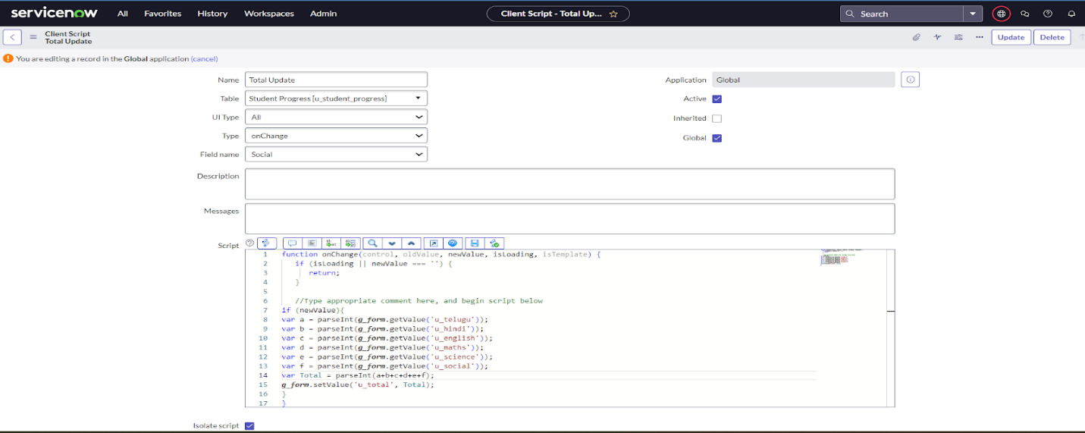

Activity 5: Creating “Result” Client Scripts for Student progress Table
Step 1. Fill the Details as given.
Step 2. Write the Code as below, Enable Isolate script and Save.
functiononChange(control, oldValue, newValue, isLoading, isTemplate) {
if (isLoading || newValue === '') {
return;
}
//Type appropriate comment here, and begin script below
if(newValue) {
var a = parseInt(g_form.getValue('u_percentage')); // Convert the value to an integer for comparison
if(a >= 0 && a <= 59){
g_form.setValue('u_result','Fail');
} else if(a >= 60 && a <= 100) {
g_form.setValue('u_result','Pass');
} else {
// Handle the case if a is out of range (optional)
g_form.addErrorMessage('Percentage should be between 0 and 100.');
g_form.clearValue('u_result');
}
}
}
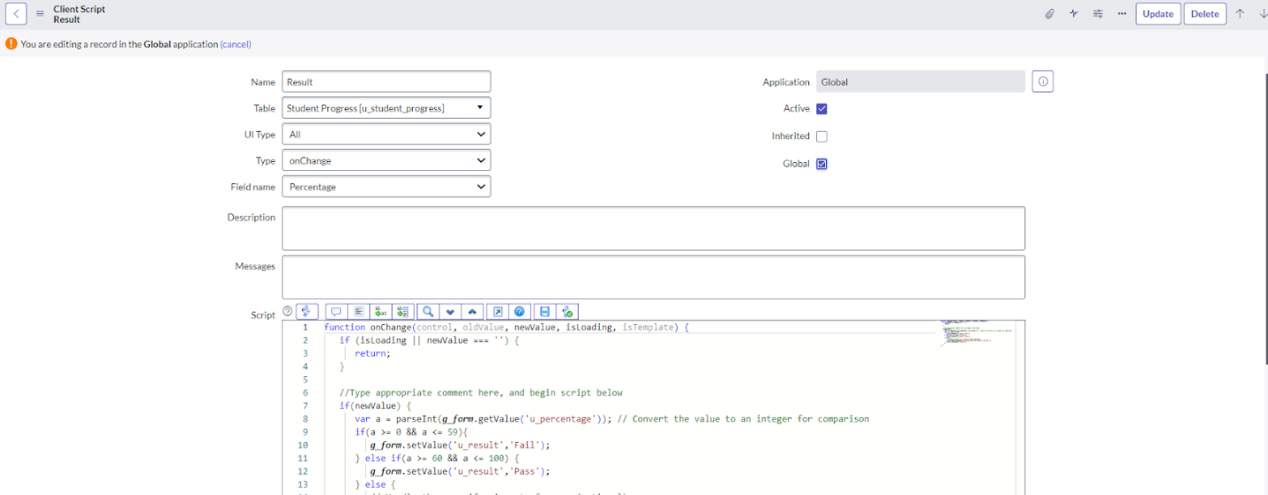

Activity 6: Creating “Percentage” Client Scripts for Student progress Table
Step 1. Fill the Details as given.
Step 2. Write the Code as below, Enable Isolate script and Save.
functiononChange(control, oldValue, newValue, isLoading, isTemplate) {
if (isLoading || newValue === '') {
return;
}

//Type appropriate comment here, and begin script below
var Total = g_form.getValue('u_total');
var Percentage = (Total/600)*100;
g_form.setValue('u_percentage',Percentage+'%');
}

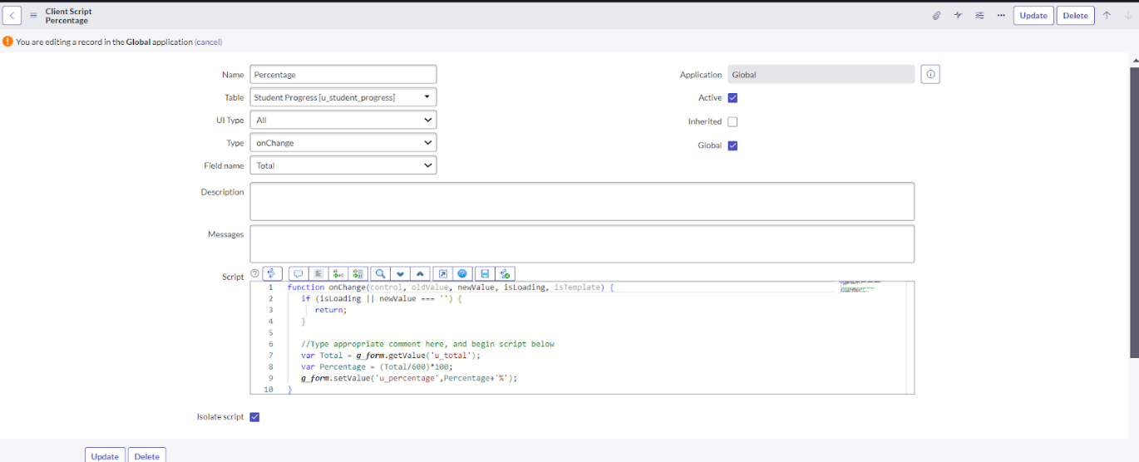

Conclusion:
The implementation of ServiceNow in educational institutions helps automate tasks, streamline workflows, and improve communication between students, staff, and administrators. It reduces response times, enhances transparency, and supports better decision-making, leading to a more efficient and effective academic environment.

